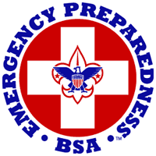

Emergency Preparedness Award
The Emergency Preparedness Award is part of a new BSA program of emphasis for Cub Scouts, Boy Scouts, Venturers, and Leaders, in cooperation with the Federal Department of Homeland Security.
All emergency activities carried out by Scouting units must be appropriate for the ages and abilities of the young people involved. Units should participate only under the supervision of their own leaders, and plans for unit help must be coordinated with community agencies responsible for disaster preparedness.

Webelos Scout Requirements
- Earn the Readyman activity badge from the community badge group.
We will do this when we return next year….
- Build a family emergency kit, with an adult family member participating in the project. Bring in your kit, and be able to describe why these contents were selected.

- With your parent or guardian's help, complete one of the following that you have not already completed for this award as a Tiger Cub or Wolf or Bear Cub Scout:
  - Take a first aid course conducted by your local American Red Cross chapter.
  - Give a presentation to your den on preparing for emergencies.
  - Organize a training program for your Webelos den on stranger awareness, Internet safety, or safety at home.

